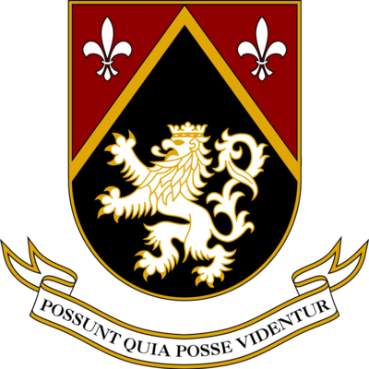
Harvard-Westlake School

Chinese Educational Cooperation Fund

Donation Pledge
Contingent on Ge (Listy) Gao’s Admission to Harvard Westlake School, Ms. Yu Bai (the donor) commit to give $100,000 to Harvard Westlake within 1 month after Listy get enrolled. The purpose is to support the Harvard- Westlake Chinese Educational Cooperation Fund (“The Fund”) founded by the Yang’s family.

Donor: Accepted by Harvard-Westlake School

—————————————————————— Date: Dec. 15, 2015

